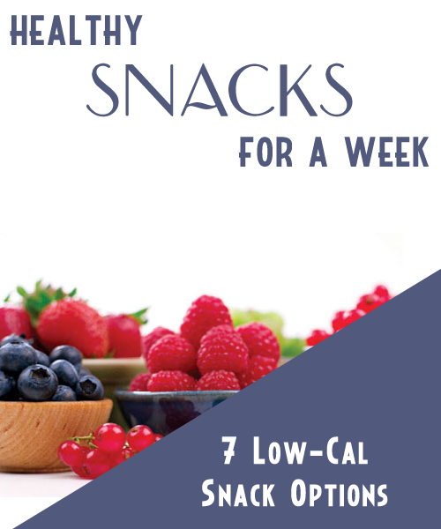
Table Of Contents

G.O.R.P 3

Sesame Carrots 3

Hummus 3

Roasted Pumpkin Seeds 3

Cheesy Popcorn 3

Toasted Nuts 3

Sun Dried Tomato Dip 3

G.O.R.P

The classic hiking accompaniment makes a great snack.

Ingredients

1/2 ounce whole shelled (unpeeled) almonds
1/4 ounce unsalted dry-roasted peanuts
1/4 ounce dried cranberries
1 tbsp chopped pitted dates
1 1/2 tsp chocolate chips

Directions

1. Combine almonds, peanuts, cranberries, dates and chocolate chips in a small bowl.

(Makes 2 Servings)

Calories Per Serving: 102
Sesame Carrots

A simple snack, but the sesame seeds add a nice touch

Ingredients

2 cups baby carrots
1 tbsp toasted sesame seeds
Pinch of dried thyme
Pinch of kosher salt

Directions

1. Toss carrots with sesame seeds, thyme and kosher salt in a small bowl.

(Makes 3 Servings)

Calories Per Serving: 33
Hummus

This fresh version of a store bought favorite will blow you away with it’s fresh taste

Ingredients

2 cups canned garbanzo beans, drained
1/3 cup tahini
1/4 cup lemon juice
1 tsp salt
2 cloves garlic, halved
1 tbsp olive oil
1 pinch paprika
1 tsp minced fresh parsley

Directions

1. Place the garbanzo beans, tahini, lemon juice, salt and garlic in a blender or food processor. Blend until smooth. Transfer mixture to a serving bowl.

2. Drizzle olive oil over the garbanzo bean mixture. Sprinkle with paprika and parsley.

(Makes 8 Servings)

Calories Per Serving: 77
Roasted Pumpkin Seeds

The Halloween favorite, is actually a nice healthy snack choice anytime of year.

Ingredients

1 1/2 cups raw whole pumpkin seeds
2 tsp butter, melted
1 pinch salt

Directions

1. Preheat oven to 300 degrees F (150 degrees C).

2. Toss seeds in a bowl with the melted butter and salt. Spread the seeds in a single layer on a baking sheet and bake for about 45 minutes or until golden brown; stir occasionally.

(Makes 6 Servings)

Calories Per Serving: 83
Cheesy Popcorn

This snack is so tasty you will think it can’t be healthy.

Ingredients

4 cups hot air-popped popcorn
1/2 cup freshly grated Parmesan cheese
Cayenne pepper, to taste

Directions

1. Toss popcorn with Parmesan and cayenne to taste.

(Makes 4 Servings)

Calories Per Serving: 75
Toasted Nuts

Nuts are full of heart healthy fats. A simple toasting will bring out their full flavor.

Ingredients

1/2 cup chopped walnuts, or nut of your choice, you can also use a mix of nuts if you want.

Directions

1. Preheat the oven to 350°F.

2. Spread the nuts out on a baking sheet.

3. Toast the nuts in the oven until they are lightly browned, about 8-10 minutes. Do NOT burn.

4. Cool and store in an airtight container for up to 2 weeks.

(Makes 8 Servings)

Calories Per Serving: 40
Sun Dried Tomato Dip

This dip is perfect for veggies, tortillas or other healthy options like melba toast.

Ingredients

1 cup sun-dried tomatoes, rehydrated
1 tbsp balsamic vinegar
1 cup non-fat cream cheese
1/2 cup non-fat sour cream
basil leaves, for garnishing

Directions

1. Puree the sun-dried tomatoes and balsamic vinegar in the food processor. Add the cream cheese and process until the mixture is smooth.

2. Add the sour cream and pulse until combined. (Be careful not to over process or the mixture will liquify.)

3. Transfer the spread to a serving bowl and garnish with fresh basil.

(Makes 10 Servings)

Calories Per Serving: 52

